**Servlet**

**What is Servlet?**

* Servlet is technology which is use for create web applications.
* Servlet is an API that provide many interfaces and classes.
* Servlet is an interface that must be implemented for creating any Servlet.
* Servlet is class that extend the capabilities of the servers and responds to incoming requests.
* Servlet is a web component that is deploy on the server to create dynamic web page.

Servlet is server side technology which is used to

* Handle the client request
* Process the request
* Generate dynamic response

Servlet Interface

|

Generic Servlet class

|

Http Servlet class

Servlet Interface – parent interface which is define life cycle methods.

Generic Servlet class – when we want to create protocol independent servlet such as HTTP, HTTPS and not having request and response object.

Http Servlet class – when we want generate get request post request method then we extend this class.

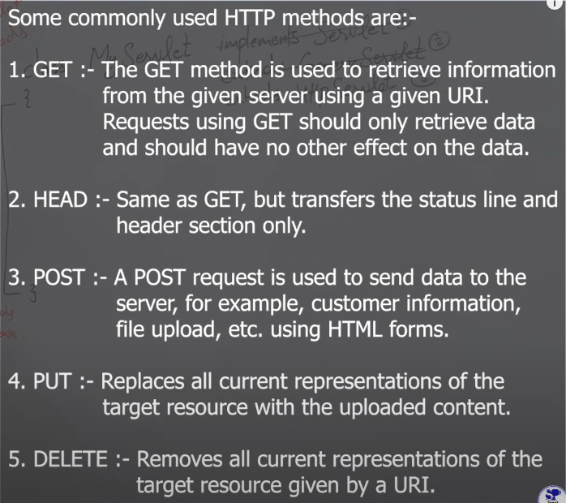

How to create Servlet?

Create class

Extend Http Servlet class

Override method like doGet or doPost and so on.

In this method provide parameter like HttpServletRequest and HttpServletResponse.

Now create logic in this method.

Configure request mapping in Web.xml file.

**Servlet Life Cycle**

* **Loading and instantiation** – when server started servlet class is loaded in the memory and servlet object is created.
* **Initialization** – **init()** – servlet object will initialized by invoking init() method.
* **Request Handling** – **service()** – it will handle the client request. In this place service() method will be invoke.
* **Destroy** – **destroy()** – when the service is shut down destroy method will be executed and servlet object will be deleted.